**ASSIGNMENT-23.1:**

Create a database named 'custom'.

Create a table named temperature_data inside custom having below fields:

* date (mm-dd-yyyy) format
* zip code
* temperature

The table will be loaded from comma-delimited file. Load the dataset.txt

(which is ',' delimited) in the table.

Database named custom is created.

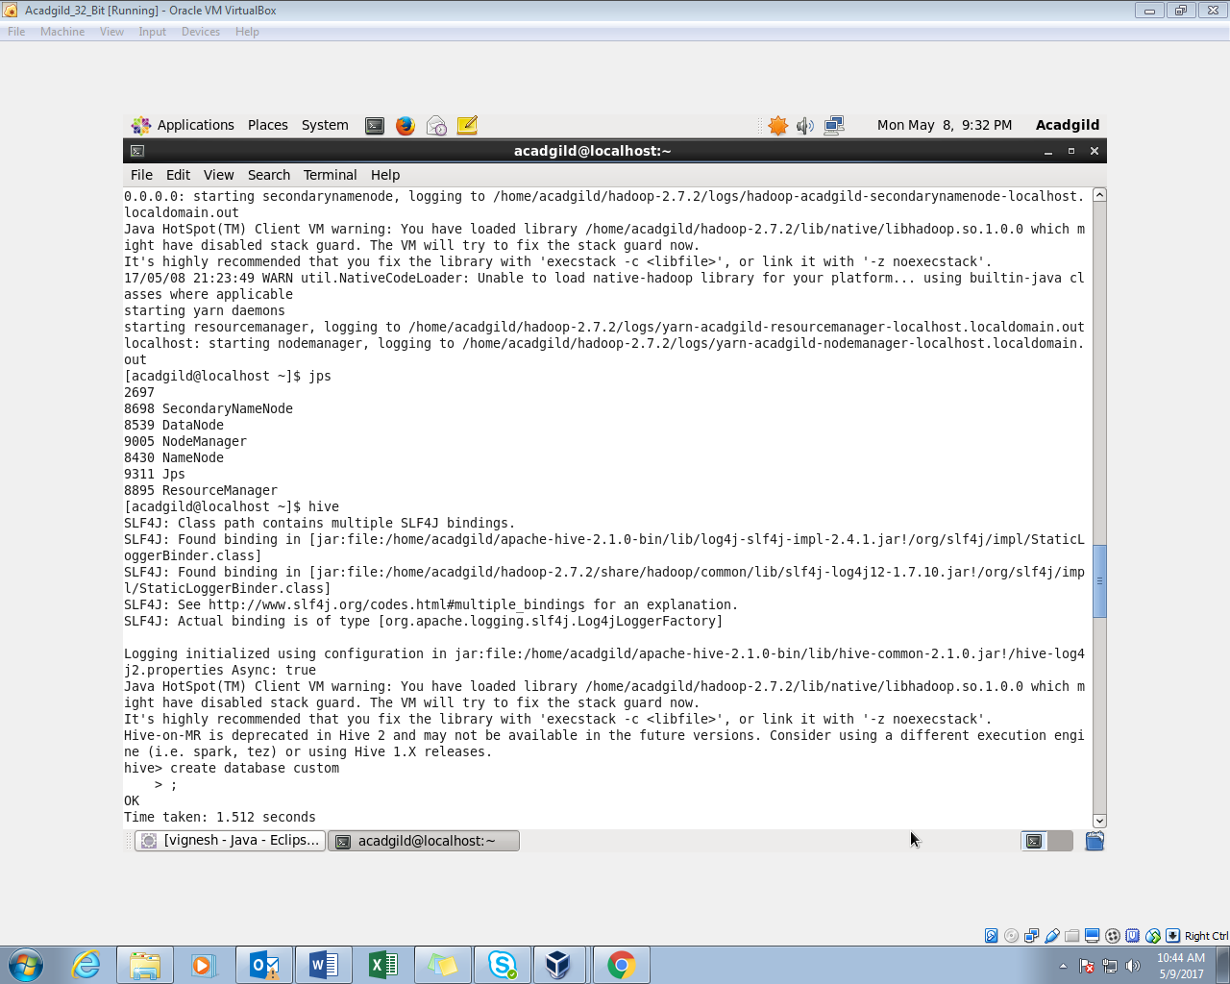

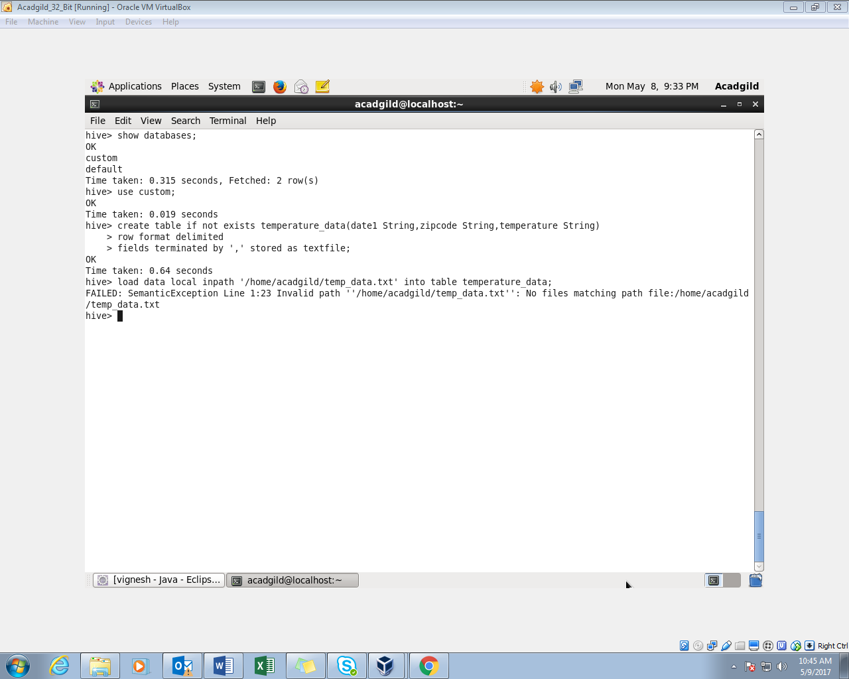

* In the below screenshot, the custom database is used.
* Then a table named temperature_data is created using the create command.
* The data is loaded from the local system. The entire contents of the table is displayed.

